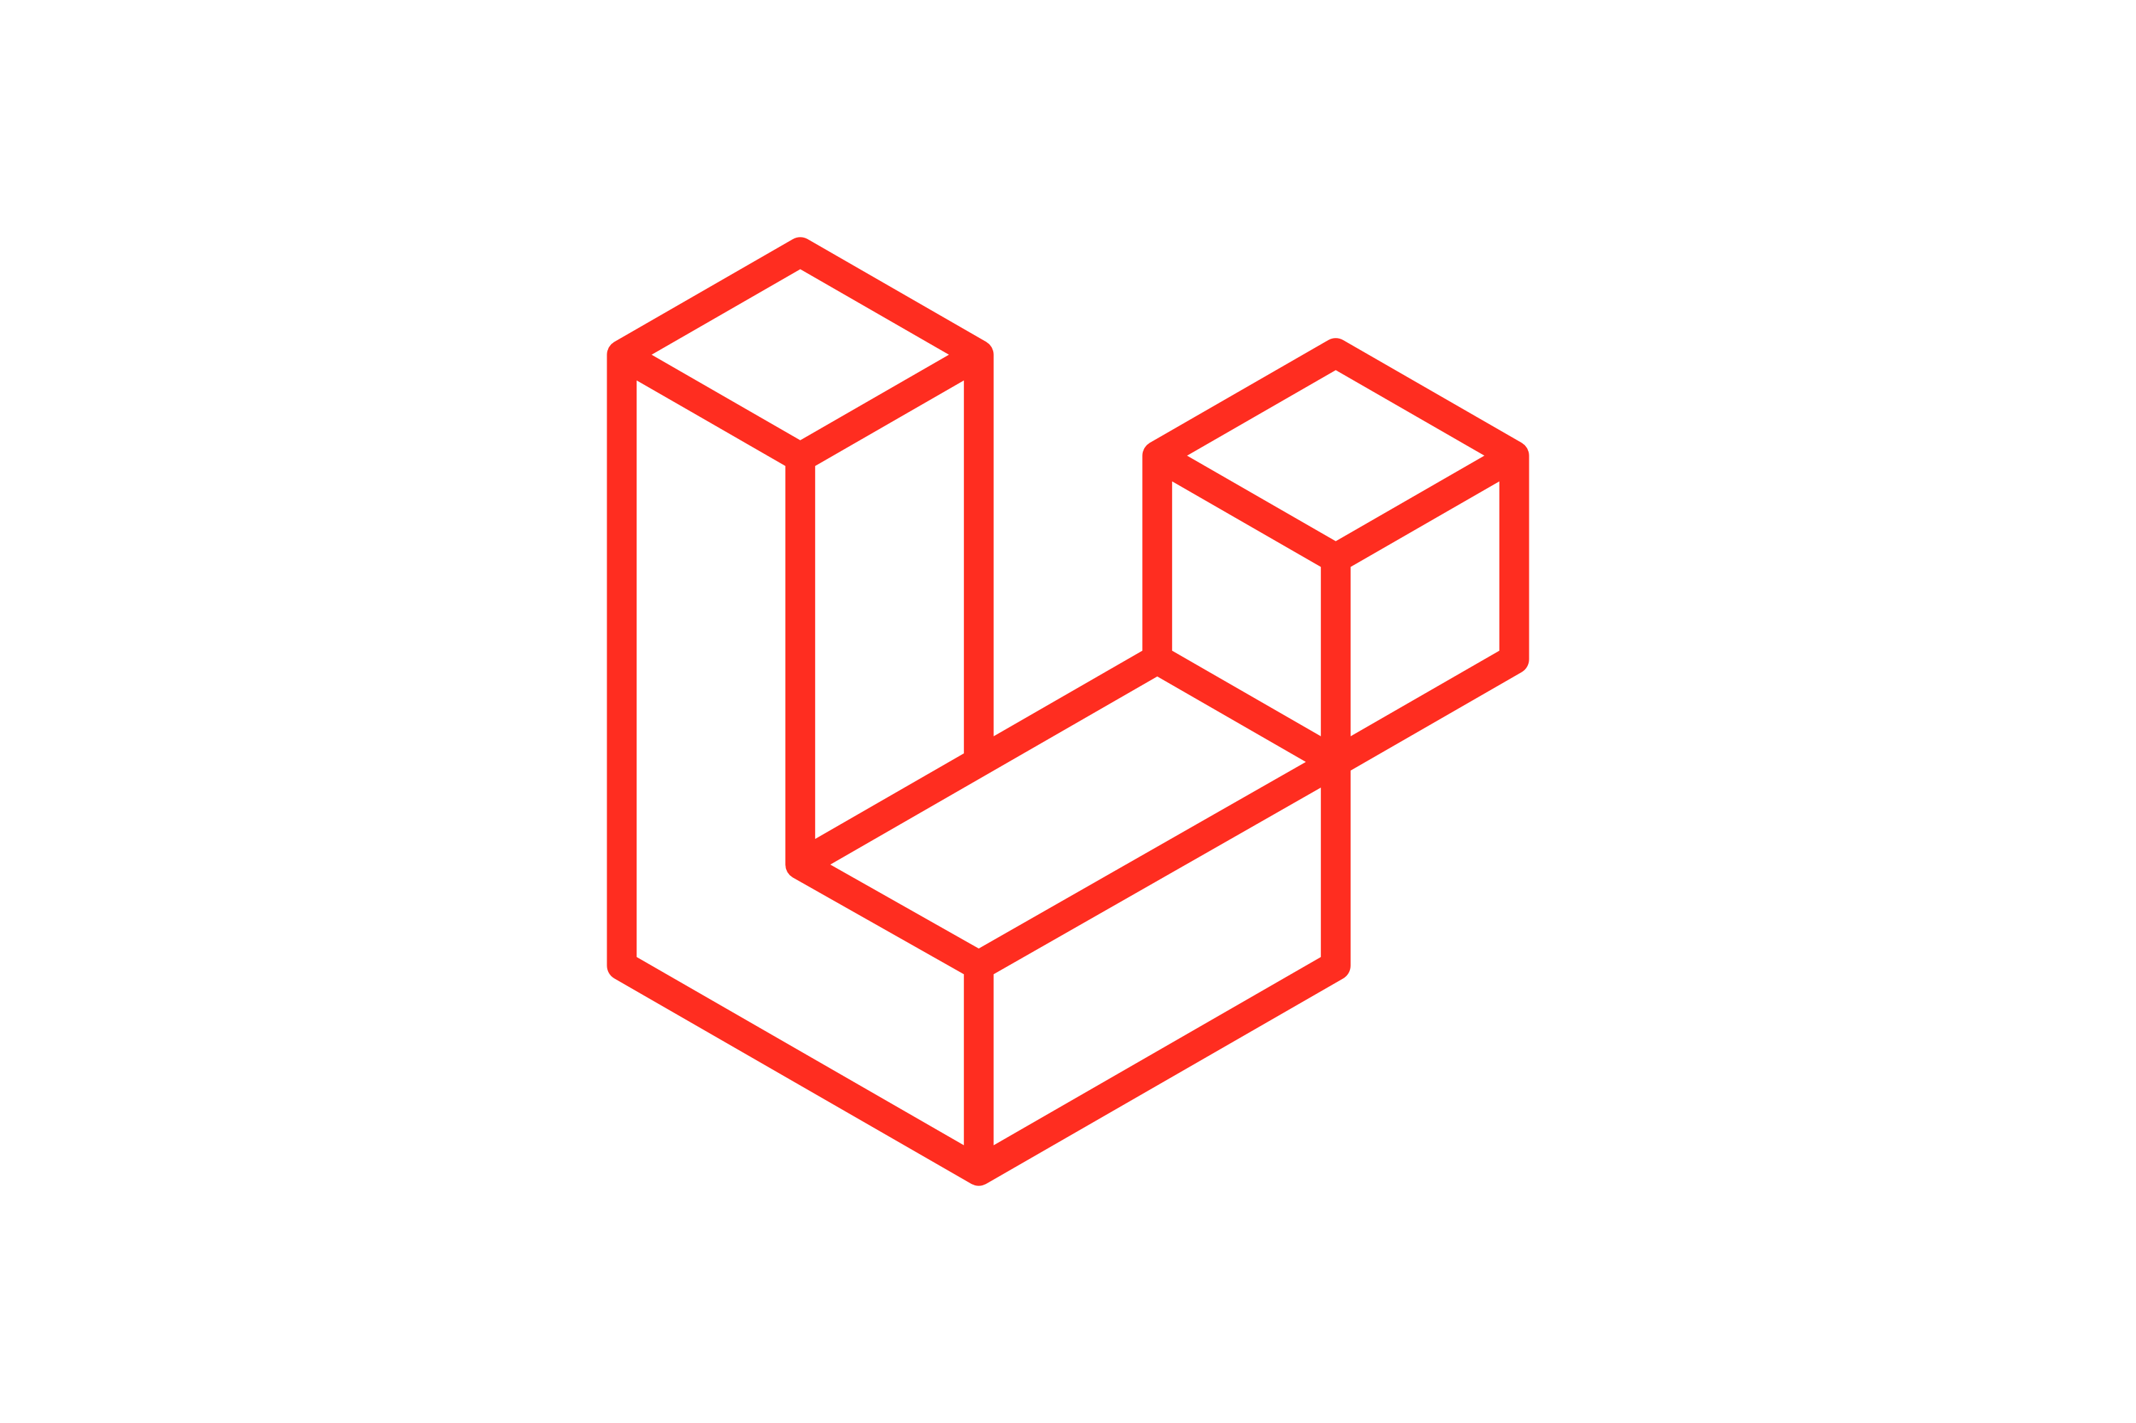


Project Setup

In your terminal:

composer create-project laravel/laravel khqr-bakong cd khqr-bakong
composer require khqr-gateway/bakong-khqr-php composer require simplesoftwareio/simple-qrcode

Then configure .env with your app name, database, BAKONG_TOKEN, etc.

Database Setup


Run migrations and create a simple products table.

php artisan make:model Product -m

Then open the migration file (database/migrations/xxxx_create_products_table.php) and add:
public function up(): void
{
Schema::create('products', function (Blueprint $table) {
$table->id();
$table->string('name');
$table->text('description')->nullable();
$table->decimal('price', 10, 2);
$table->string('image')->nullable();
$table->timestamps();
});
}

Run:

php artisan migrate

Then seed some sample products:

Product::create([

'name' => 'iPhone 17 Pro', 'description' => '128GB, Blue Titanium', 'price' => 200,
'image' => 'https://i.ebayimg.com/images/g/EDEAAeSwLb9owuv8/s-l1600.webp'
]);
Product::create([
'name' => 'AirPods Pro 3',
'description' => 'Wireless earphones with noise cancelling', 'price' => 150,
'image' => 'https://sm.mashable.com/t/mashable_sea/article/a/apple-airp/apple-airpods-pro-3-every-single-thing-we-know-so-far_uj6k.1248.jpg'
]);

php artisan db:seed

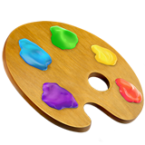
ProductController

Create controller:

php artisan make:controller ProductController

Add code:
<?php

namespace App\Http\Controllers; use App\Models\Product;
class ProductController extends Controller
{
public function index()
{
$products = Product::all();
return view('products.index', compact('products'));
}

public function show($id)
{
$product = Product::findOrFail($id);
return view('products.show', compact('product'));
}
}

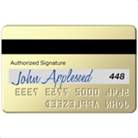
PaymentController (Bakong Integration)

php artisan make:controller PaymentController

Add code:
<?php

namespace App\Http\Controllers;

use Illuminate\Http\Request; use App\Models\Product;
use KHQR\BakongKHQR;
use KHQR\Helpers\KHQRData;
use KHQR\Models\IndividualInfo;
use SebastianBergmann\Environment\Console;

class PaymentController extends Controller
{
public function checkout($id)
{
$product = Product::findOrFail($id);

// Your merchant info (replace with real Bakong account)
$merchant = new IndividualInfo( bakongAccountID: vatana@bkrt, merchantName: VUTH VATANA', merchantCity: 'Phnom Penh', currency: KHQRData::CURRENCY_KHR, amount: $product->price
);
$qrResponse = BakongKHQR::generateIndividual($merchant); return view('products.checkout', [
'product' => $product,
'qr' => $qrResponse->data['qr'] ?? null, 'md5' => $qrResponse->data['md5'] ?? null,
]);
}

public function verifyForm()
{
return view('payments.verify');
}

public function verifyTransaction(Request $request)

{
$request->validate([
'md5' => 'required|string',
]);

try {
// Your Bakong API token from https://api-bakong.nbc.gov.kh/register
$token = env('BAKONG_TOKEN'); // put it in .env
$bakong = new \KHQR\BakongKHQR($token);
$result = $bakong->checkTransactionByMD5($request->md5); return response()->json($result);
// return view('payments.result', ['result' => $result]);
} catch (\Exception $e) {
// return back()->withErrors(['error' => $e->getMessage()]); return response()->json(['error' => $e->getMessage()], 500);
}
}

public function paymentResult()
{
return view('payments.result');
}
}

Routes


Edit routes/web.php:
<?php

use Illuminate\Support\Facades\Route;
use App\Http\Controllers\ProductController; use App\Http\Controllers\PaymentController;

Route::get('/', [ProductController::class, 'index'])->name('home'); Route::get('/product/{id}', [ProductController::class, 'show'])->name('product.show'); Route::post('/checkout/{id}', [PaymentController::class, 'checkout'])-
>name('checkout');
Route::get('/verify', [PaymentController::class, 'verifyForm'])->name('verify.form'); Route::post('/verify', [PaymentController::class, 'verifyTransaction'])-
>name('verify.transaction');
Route::get('/payments/result', [PaymentController::class, 'verifyTransaction'])-
>name('payments.result');


Views

resources/views/products/index.blade.php
@extends('layouts.app')

@section('content')
<div class="container">
<h1>Product List</h1>
<div class="row"> @foreach($products as $product)
<div class="col-md-4">
<div class="card mb-3">
<img src="{{ $product->image }}" class="card-img-top" alt="{{
$product->name }}">
<div class="card-body">
<h5>{{ $product->name }}</h5>
<p>{{ $product->description }}</p>
<p><strong>{{ number_format($product->price, 0) }} ៛</strong></p>
<a href="{{ route('product.show', $product->id) }}" class="btn btn-primary">Buy</a>
</div>
</div>
</div> @endforeach
</div>
</div>
@endsection

resources/views/products/show.blade.php
@extends('layouts.app')

@section('content')
<div class="container">
<h1>{{ $product->name }}</h1>
<img src="{{ $product->image }}" width="200">
<p>{{ $product->description }}</p>
<p><strong>{{ number_format($product->price, 0) }} ៛</strong></p>

<form action="{{ route('checkout', $product->id) }}" method="POST"> @csrf
<button class="btn btn-success">Generate KHQR to Pay</button>

</form>
</div> @endsection


resources/views/products/checkout.blade.php
@extends('layouts.app')

@section('content')
<div class="container text-center">
<h1>Scan KHQR to Pay</h1>
<p><strong>{{ $product->name }}</strong> — {{ number_format($product->price, 2) }} $</p>

@if ($qr)
{!! QrCode::size(300)->generate($qr) !!}
<p class="mt-3">MD5: {{ $md5 }}</p>
<p class="text-muted">Scan this QR code using Bakong App to make a payment.</p>
@else
<p class="alert alert-danger"> Failed to generate KHQR.</p> @endif

{{-- Countdown Timer --}}
<div class="mt-4">
<h3 id="countdown" class="text-danger fw-bold">120</h3>
<p class="text-muted">This page will expire in <span id="seconds">120</span> seconds.</p>
</div>

<a href="{{ route('home') }}" class="btn btn-secondary mt-4">Back to Shop</a>
</div>

{{-- Countdown Script --}}
<script>
let timeLeft = 120; // seconds
const countdownElement = document.getElementById('countdown'); const secondsText = document.getElementById('seconds');

const timer = setInterval(() => { timeLeft--;
countdownElement.textContent = timeLeft; secondsText.textContent = timeLeft;
if (timeLeft > 0) {
fetch("{{ route('verify.transaction') }}", { method: "POST",

headers: {
"Content-Type": "application/json", "X-CSRF-TOKEN": "{{ csrf_token() }}"
},
body: JSON.stringify({ md5: "{{ $md5 }}"
})
})
.then(response => response.json())
.then(data => { console.log(data);
if (data.responseCode === 0) { clearInterval(timer); alert("Transaction successful!");
window.location.href = "{{ route('home') }}";
} else if (data.failed) {
alert("Transaction failed. Please try again.");
}
})
.catch(error => console.error('Error:', error));
}
if (timeLeft <= 0) { clearInterval(timer);
window.location.href = "{{ route('home') }}";
}
}, 1000);
</script> @endsection

resources/views/layouts/app.blade.php
<!DOCTYPE html>
<html>
<head>
<title>Bakong KHQR Shop</title>
<link href="https://cdn.jsdelivr.net/npm/bootstrap@5.3.3/dist/css/bootstrap.min.css" rel="stylesheet">
</head>
<body>
@yield('content')
</body>
</html>


Run the Project

php artisan serve

Visit:
 http://127.0.0.1:8000

You’ll see product cards — click Buy, then it will generate and show a KHQR code using your Bakong account ID.

 Notes

- Replace 'yourbakongid@bankcode' with your actual Bakong Merchant Account ID.
- If you want to verify payments, you can extend the PaymentController using:
- $bakong = new BakongKHQR('your_api_token_here');
- $bakong->checkTransactionByMD5($md5);
- To test with real Bakong QR scanning, use the Bakong app and scan the generated QR image.

